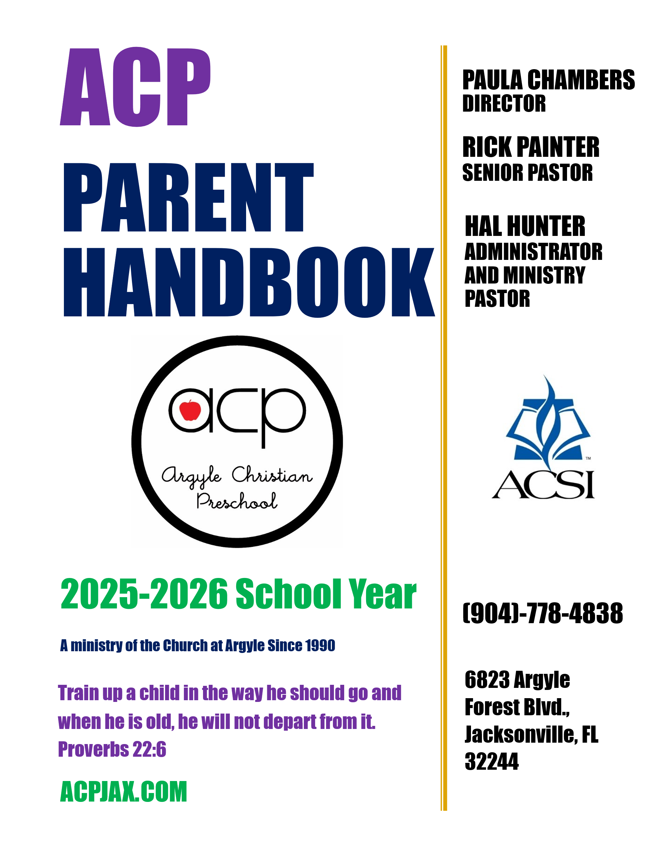
ITEM  Table of Contents | PAGE
Statement of Faith  Philosophy  Vision Statement/Mission Statement/Objectives  Core Values  ACP School Board/Preparing your Child for School/ACP Entry Procedures  Fees/Tuition, Financial Information  Admission Requirements/Non-Discrimination Policy  School Policy  - School Days/Holidays, Class Size, Clothing  - Snacks/Lunch, Birthdays, Holiday Parties, Illness/Accidents  - Allergies, Medication, Toys, Show and Tell  - Communication:  Parent Teacher Conferences, Conflict Resolution, brightwheel  - Portfolios/Assessments, Open House  - Open House/Emergency/Security Procedures  Parking Lot, Fire/Tornado Drills/Weather Emergencies, Release of Children  - Visitation  - Volunteering/Fundraising:  PTF, Fundraising, Volunteering  - Field Trips  - Withdrawals, Child Abuse/Bullying  - Guidelines for Discipline  - Dismissal  - Parent Code of Conduct  - ACP Extended Day  - ACP Plan for Children with Suspected Developmental Delays  Pandemic Policy  Technology  The Two Year Old, Characteristics and Daily Program  The Three Year Old, Characteristics and Daily Program  The Four Year Old, Characteristics and Daily Program  Expected Outcomes | 1  2  3  4  5  6  7  8  11  12  13  14  16  17  18  20  21  22  24  26  28-32
 | Rev 10/2025

STATEMENT OF FAITH

In the belief that all Christians share responsibility for the education and preservation of our children, we commit ourselves to providing the best possible God-centered, educational opportunities to the families of The Church at Argyle and the surrounding community.

The Argyle Christian Preschool educational program will be based upon the following truths:

God

God is the eternal, supreme, sovereign, and holy God in whom resides all knowledge, truth and wisdom. Psalm 90:2, Proverbs 2:6, Isaiah 44:6

God’s Word

The Bible is the authentic, complete, divinely inspired, inerrant, holy, Word of God. It is the source of all truth and the center of all learning. II Timothy 3:16-17, Psalm 33:4

Jesus Christ

Jesus Christ is the incarnate Son of God; the only way by which we can be reconciled to the Heavenly Father and acquire eternal life. John 1:4,3:15, 14:6 and Luke 1:35

Holy Spirit

The Holy Spirit is that part of the Trinity, which indwells and empowers all believers to live a holy and godly life. John 14:26, Ephesians 4;30, 5:18b

Knowledge and Wisdom

Knowledge is the acquisition of God’s truth, while wisdom is the God-given ability to correctly apply that acquired knowledge. Proverbs 2:6, Psalm 25:4

Education

True education is the process whereby we learn to see truth through the perspective of God’s Word. Proverbs 3:5-8

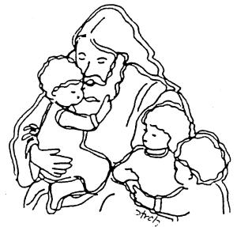

PHILOSOPHY

Research has revealed the importance of the formative years, thus increasing the emphasis on early childhood education. Children’s minds, bodies and spirits develop most rapidly and with extreme ease during this time. Their experiences significantly influence their overall development and attitudes. The effectiveness of a program plays a vital part in preparing the child for future success. The key to success is in the realization that children are individuals, developing at their own pace and having distinct needs, varying learning styles and abilities. Concepts regarding God, Jesus, the Bible, church, self, family, the natural world and others are the basis for our curriculum. Developmental/Biblical education teaches children by meeting the developmental needs of the child and by teaching the values of the Judeo/Christian faith.

The teacher’s knowledge and understanding of early childhood development influences judgment and attitudes concerning children. It is vital that teachers accept each child as “unique” and not expect uniformity in their reactions to experiences. Our program is designed through the “learning center” approach which allows children to be children in an enriched environment. Just as the Bible states in Luke 2:52, “Jesus grew in wisdom and stature and in favor with God and men”, our curriculum provides for intellectual, physical, moral/spiritual, emotional, and social growth.

Meeting needs at the appropriate time is essential. Children who are exposed to experiences before they are developmentally ready often encounter feelings of frustration and failure. Children who are “ready” but whose needs are neglected can become bored. This could have a detrimental effect because the ability to experience success is one of the greatest stimulators. A child’s ability to function and learn in the classroom environment is also dependent upon the climate, setting and materials. We provide a warm, loving climate
where children feel cared for and secure, thereby enabling them to be receptive to new experiences. The physical environment is bright, varied and stimulating with numerous materials of various levels of difficulty provided in order to meet individual interests and developmental needs.

Biblical values and concepts that young children can understand about God’s creation, His love for us, His plan for families, and our relationship to others are reinforced in a nonthreatening manner throughout the program. We incorporate our praise, thanksgiving, and concern for others in daily activities. While remaining sensitive to the fact that many children have non-traditional family relationships, we reinforce the traditional family lifestyle. Multicultural values are instilled as we teach that God has a different plan for each unique, special individual. Biblical truths will also enable children to evaluate right and wrong and make wise choices for their own behavior.

Our program focuses on the child by identifying individual needs and providing experiences and materials that promote healthy growth and development. In realizing that “growth is an exemplification of the principle of continuity,” materials and experiences are related in an organized and sequential manner. They move from that which is familiar to broader unknown experiences. The program values the role of the teacher as caregiver, guide, stimulator, and facilitator. It strives to give each child a strong foundation upon which to build further knowledge and success. It encourages parental involvement because early childhood programs are not a substitute for the home, but rather an extension of it.
VISION STATEMENT

Our Vision at ACP is Educate, Equip, and Prepare students for their next steps, through Jesus, from the Inside-Out!

MISSION STATEMENT/OBJECTIVES

Our mission is Growing Kids God’s Way.

Objectives:

- To teach the love of God and the promise of eternal life for the purpose of bringing children to a saving knowledge of Jesus Christ. John 14:6

- To develop a child-centered program acknowledging that learning is sequential and happens at different times according to each child’s individual growth and maturity. Proverbs 3:1-6

- To provide a program for the intellectual, physical, social, emotional, and spiritual needs of the children. Luke 2:52

- To provide opportunities for each child to recognize long-term rewards for good choices by focusing on successes as the child’s building blocks for learning and developing Christian character. Matthew 6:19-21, II Timothy 2:15

- To uphold the family by providing opportunities for the involvement of parents and other adults in the educational process, recognizing that the school is an extension of the home. Deuteronomy 6:6-7

- To develop a program which provides a warm, enthusiastic, highly competent staff who recognize the importance of setting the proper example as role models of the Christian life. Psalms 84:11

- To provide a program that will represent The Church at Argyle as a valuable in-reach and out-reach ministry. Matthew 5:16, Acts 1:8
CORE VALUES OF ACP

Integration of the Truth- We believe that God’s Word is truth (John 17:17) and that God’s truth should be woven in the fabric of every activity of the school, including curriculum and extracurricular activities.

Character Development- We believe in providing opportunities for each child to recognize long-term rewards for good choices by focusing on success as the child’s building blocks for learning and developing Christian character. (Matthew 6:19-21, II Timothy 2:15.) We are committed to teaching children to love God and to love others as themselves. (Matthew 22: 37-39)

Godly Staff - We are committed to hiring exceptional employees who honor and love God and who have a love and passion for children. Our employees are warm, enthusiastic, highly competent and they recognize the importance of setting the proper example as role models of the Christian life. (Psalms 84:11). They must be called by God to their positions at ACP and demonstrate excellence in the classroom setting.

High Academic Standards, Diversity of Learners- ACP is committed to providing a child-centered program that acknowledges that learning is sequential and happens at different times according to each child’s individual growth and maturity. (Proverbs 3:1-6) Our learning environment is a developmentally appropriate setting in which the intellectual, physical, social, emotional, and spiritual needs of the children are met. (Luke 2:52). This approach results in students that are equipped with skills and accomplishments allowing them to excel in future academic settings.

Good Stewardship- Acknowledging that God owns all things, ACP desires to honor Him in all financial decisions (I Chronicles 29:11). We are committed to being faithful stewards of all God has entrusted to us. We are committed to spending only what He provides through a balanced annual budget. A significant portion of the school’s budget is attributed to the salaries of our employees. We place a high value on our employees and understand the financial sacrifice that is made on their part in order to fulfill their calling.

Ministry- ACP desires to represent The Church at Argyle as a valuable in-reach and out-reach ministry by partnering with families. (Matthew 5:16, Acts 1:8) As servants in this ministry, we have a responsibility to follow Christ’s example, learning to become good servants and Disciples of Christ. As servants, we serve both our church and our community at large.

Excellence and Integrity - ACP teaches a Biblical, developmentally appropriate curriculum and provides outstanding, innovative educational programs that prepare our students for success in life. The staff’s exemplary lifestyles are reflective of Christian ethics with accountability to Christ, each other, our students, and our community. (Titus 2:7-8a; I Corinthians 4:1-2; Romans 5:1-5, Philippians 1:9-11; Romans 12:1-6a)

ACP SCHOOL BOARD

Argyle Christian Preschool is governed by the ACP School Board. The School Board oversees the continuing operation of ACP and generally oversees the school’s business affairs. The responsibilities include but are not limited to; making policy; acting on matters of personnel; establishing tuition and fees and promoting Christian education in the community and praying for the ministry of the school.

The School Board is comprised of the Senior Pastor of the Church at Argyle, Administrator and Ministry Pastor, Children’s Ministry Director, ACP Director and Financial and Administrative Assistant,
as well as 6 church members.

PREPARING YOUR CHILD FOR SCHOOL

School is going to be a new and great experience for your child. It is worthwhile for parents to help their child overcome the fear of facing new situations. You may help prepare your child by:
- Always speaking of going to school as a pleasant, joyous event.

- Taking time to talk with your child about the new experiences they will have so that they will look forward with pleasure to their first important year in school.

- Preparing your child for the fact that he/she will be left alone in school to enjoy the company of other children.

- Knowing the teacher. Your child will be happy and secure if they know that their teacher and parents are friends. The first days of school can be a very happy or unhappy experience for your child. You can help your child on these first few days by guarding your words and actions. When the child realizes that you are not available, he will accept the teacher’s guidance more readily. We suggest that you place your child in the hands of the teacher, assure them that you will return, and leave promptly. The school will be happy to have you visit at a later date.

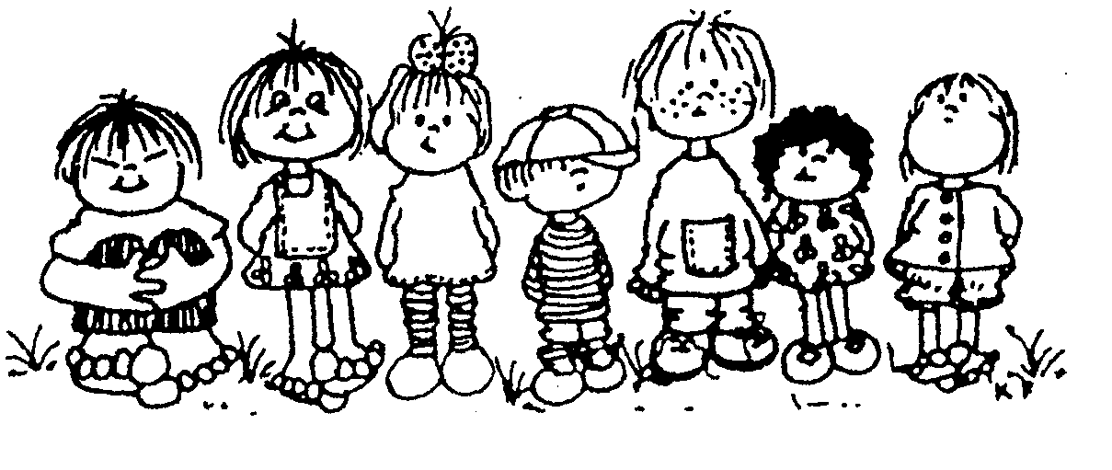

ACP ENTRY PROCEDURES

Your child will be dropped off and picked up in car line each day. Car line will begin 10 minutes before class begins. You will sign your child in at the car, by scanning the Brightwheel QR code provided by a staff member then you will enter the pin that you chose when setting up the app on your electronic device. Your child’s ACP sign that will be given to you at your classroom visit should be placed in the window of your car for morning and afternoon pick-up, then you will scan the QR code and enter your pin again for your child to be released.

School begins at 9am for all students. If you arrive after car line is done, you must come to the school office doors in building B, the check-in procedure will be done at the door.

For morning and afternoon pickup in extended care, you must go to the school office doors in building B, ring the doorbell, then scan the Brightwheel QR code at the door. If you arrive after 8:40am, you will have to join car line for drop off.

2024-2025 Fee Schedule
Class | Commitment Fee * | Monthly Tuition
Twos T/Th | $275 | $360
Twos T/W/Th | $295 | $445
Twos Mon-Thurs | $305 | $495
Threes T/Th | $275 | $360
Threes M/W/F | $295 | $450
Threes Mon-Fri | $310 | $570
Threes Full Time | $320 | $870
VPK M-Th | $0 | $0
VPK M-F 9-12:30 | $0 | $90
VPK 4day + Full time extended care | $220 | $445
VPK 5day + Full time extended care | $230 | $555
**Prices are subject to change with reasonable notice

Tuition payments are due on the first of each month. The total program cost has been divided into 9 equal monthly payments for your convenience. Absences, holidays, and closings due to extreme weather are not deductible.

Preschool begins August 13, 2025. The last day of school is May 13, 2026.

Please do not bring your child prior to or after his/her scheduled hours. Please be on time. Your child may feel uncomfortable about arriving after everyone else has become involved in activities. Please do your best to have your preschooler in class on time. If you are tardy, you must come to the office for admission rather than carline.

Attendance during the scheduled instructional days is of the utmost importance in remaining in the VPK program. Funding for VPK is linked to attendance and attendance is necessary for successful progression from VPK to Kindergarten. Being consistently late for VPK or preschool will be grounds for dismissal.

Each VPK parent must sign an Attendance and Tardiness Policy agreement. Failure to abide by this agreement will result in dismissal.

There is a $25.00 service charge on all returned checks. After two returned checks, tuition must be paid by cash or money order. A $25.00 delinquent fee will be charged to your account after the 15th of each month, for unpaid tuition, unless advance arrangements have been made with the director or bookkeeper. Unless arrangements have been made with the director, two months delinquency will result in cancellation of enrollment.

There will be a late pick up fee of $25.00 for any part of the first half hour after dismissal time for preschool, and an additional $25 for each 15 minutes thereafter for pick- ups after your scheduled pick-up time. There is no grace period for late pick-up after 6pm for extended care. Late-pick up results in employee overtime and will cost $25 at 6:01 pm and each 15 minutes thereafter.
All account balances must be current prior to registration for the next school year. Balances cannot be carried over from one school year to another. Accounts more than 60 days past due will be referred to our collection agent. End of the year progress reports and scrapbooks will not be released until balance is paid.

ADMISSION REQUIREMENTS

Argyle Christian Preschool is accredited through the Association of Christian Schools, International (ACSI). The school operates under a Florida religious exemption certificate and is not licensed by the Florida Department of Children and Families (DCF). ACSI is a recognized accrediting organization in the State of Florida and offers an approval program for faith-based schools operating under religious exemption. We have met or exceeded all applicable requirements and guidelines set forth through the ACSI approval program. Parents are required to comply with the following:

- A registration form must be completed and accompanied by the annual non-refundable commitment fee. (for students utilizing programs other than VPK)
- A DCF Certificate of Medical Exam (3040) and a Certificate of Immunization (680) is required for each child. A physical is valid for two years. Immunization records must be updated as indicated by the expiration date on the form. You will be informed in advance of approaching expiration dates, so that you may update forms before they expire. Children cannot remain enrolled with expired forms. These documents must be signed by your family physician and should contain a statement of the child’s general health including any significant medical conditions such as allergies or physical limitations. Your physician has these forms in his office. We must have these forms on file within 15 days of your child’s enrollment date.
- A copy of your child’s birth certificate is required.
- An Information/Enrollment form is required before the child begins school. The statement pertaining to our discipline policies, philosophy, Vision & Mission Statements, Objectives, Core Values and Statement of Faith must be signed.
- An Authorization for Emergency Medical Attention must be signed and notarized by a parent or guardian.
- Children are placed in rooms according to age and accommodations.

Non-Discrimination Statement Consistent with Christian principles, Argyle Christian Preschool admits students of any race, color, national or ethnic origin, gender, or religion to all the rights privileges, programs, and activities generally accorded or made available to students at the school.
- Argyle Christian Preschool does not discriminate on the basis of race, color, national or ethnic origin, gender, or religion in administration of its educational policies, admissions policies, and other school-administered programs.
- Argyle Christian Preschool is an "equal opportunity employer.” ACP will not discriminate and will take "affirmative action" measures to ensure against discrimination on the basis of race, creed, color, national origin, or gender in employment, recruitment, compensation, termination, upgrading, promotions, and other conditions of employment for all employees or job applicants.
- Faith is not a factor in the admission process for students but is a daily part of life for students including participation in Biblically based activities as well as Chapel services. A statement of faith for Argyle Christian Preschool can be found on the website as well as in the student handbook.
SCHOOL POLICY

SCHOOL DAYS/HOLIDAYS

August 12, 2025, at 7:00 pm Preschool/VPK Orientation
August 13, 2025 First Day Preschool
August 13, at 9:30 a.m. Preschool/VPK Orientation
September1, 2025 Labor Day No School
November 11, 2025 Veteran’s Day No School
November 26-28,2025 Thanksgiving Break No School
Dec 9, 2025-Jan 1, 2025 Christmas Break No School
January 2, 2026 Planning Day No School
January 19, 2026 Martin Luther King Day No School
February 16, 2026 President’s Day No School
March 12, 2026 Spring Fling Early Release
March 13, 2026 Planning Day No School
March 16-20, 2026 Spring Break No School
April 3, 2026 Easter (Good Friday) No School
April 24, 2026 Parent/Teacher Conference Day: NO School
May 12, 2026 VPK/4-year-old Celebration
May 13, 2026 Last Day of School

Preschool classes begin at 9:00 a.m. and end at 12:30 p.m. for 2s, 3s and 5 day VPK. The 4-day VPK classes begin at 9:00 a.m. and end at 1:00 p.m. We follow Duval County Schools in closing due to weather conditions. Unless you are otherwise notified by your child’s teacher, please stay tuned to local weather reports.

CLASS SIZE

One strategy toward educational excellence is small class size. For this reason, the preschool maintains the following ratios:

Class Teacher to Child
Two-Year Olds 1 to 6
Three-Year Olds 1 to 8
(VPK) Four-Year Olds 1 to 8
Extended Care 1 to 9

CLOTHING

Send children in comfortable, washable clothing. Straps or complicated buttons and belts that can cause frustration must be avoided. If one-piece outfits are worn, the children must be able to get in and out of them by themselves. Children should wear shoes suitable for outside play. Backless shoes and traditional style CROCS will not be permitted. These types of shoes can be dangerous on the playground, as they tend to slip off or get mulch inside of them.

Please label all clothing, especially sweaters, coats, raincoats, etc. with your child’s name. Preschool children need a complete change of clothing (marked) in case of an accident. If we have to dress them in some of our clothing, please launder and return the clothing to the school. Please switch these clothes out when seasons change, so that they are seasonally appropriate.
SNACKS/LUNCH

Snacks, lunch, and drinks are parent provided. They should be nourishing and something the child will eat. The USDA recommends that lunches include 1 serving of 1 ½-2 oz of protein, 1 serving of ½ - ¾ cup fruit, 1 serving of ½ - ¾ vegetables, and ½ slice of bread. Snacks should be “child-friendly” (something the child can manage). PLEASE no Kool-Aid, soft drinks or sugared foods. Candy included in lunches will be sent back home, unopened. Please remember that ACP is a “No Nut Zone”. Because of the number of peanut/nut allergies, we ask that you please refrain from sending nut products or products prepared in a factory that uses peanuts/nuts in your child’s snack/lunch. Please remember when packing snacks, it is not ACP policy to heat food. When classes prepare their snacks as part of the curriculum, parents will be notified. However, this does not replace the regular morning snack time. Preschool children need to be fed breakfast before attending school and must not enter the classroom finishing their breakfast. Extended care students may consume their breakfast in extended care before Preschool begins.

BIRTHDAYS

Birthdays are very special occasions to preschoolers. We would love for the school to be a part of these special days but ask that parents follow the school guidelines. Birthday treats (such as cupcakes for the class) are to be arranged with teachers in advance. No gift exchanges. Invitations to private parties after school hours may be distributed in the classroom only if each child receives an invitation.

HOLIDAY PARTIES

You may be asked to furnish refreshments, favors, games, time and so forth for holiday parties. A sign-up sheet will be posted for requested items. If you are able, please contribute to these occasions. Parent involvement is an important part of the school experience for both parents and children.

ILLNESS/ACCIDENTS

In the event of illness, ACP follows a 24 Hour Rule. A child who leaves or misses school with one of the symptoms listed below may not return to class until he/she has been symptom free without medication for at least 24 hours.:

- Temperature above 100.3 degrees orally
- Vomiting
- Diarrhea
- Stiff neck associated with flu-like symptoms
- Conjunctivitis (pink eye)
- Contagious rash
- Head Lice (student must be nit-free)
- Uncontrolled coughing

If a child becomes ill while in our care, his/her parents will be notified, and the child must be picked up immediately. The child will be cared for in a temporary area and supervised by an adult until the parent arrives. If the parents cannot be reached, a designated adult will be notified. An adult must be available within a 15/20 minute radius to pick up the child.

If a child contracts a communicable disease, the parent must notify the Director.

A first-aid kit will be used for minor incidents. In the event of a major incident, the Director will make contact decisions. Parent notification will be made as soon as the child’s immediate needs are met. Parents must keep the school office up to date with personal information and emergency numbers to avoid delays in the event of an emergency.

ALLERGIES

The school must be informed of any allergies that your child may have and give complete written documentation on how to handle the allergy if necessary. Because of the common occurrence of peanut allergies, ACP is a “No Nut Zone.” We ask that you refrain from bringing nut products for snacks, parties, goody bags, etc. Cooperation is both necessary and appreciated!

MEDICATION

If a child needs prescribed medicine during the day, he must have a “medication form” filled out stating the time and quantity of medicine needed; otherwise, we cannot dispense it. It must be in its original bottle. Over the counter medication without a doctor’s order will not be administered unless a child is registered in full-time care. In this case, a parent must fill out a medical authorization form. Place medication, medicine spoon and the form in a small bag bearing the child’s name. Medication will be kept in the Preschool office in a locked cabinet, or if needed, in the refrigerator. If a child has an epi-pen, it will be placed in the teacher’s emergency bag that goes everywhere with the child.

TOYS

Since it is difficult for young children to share personal toys, we ask that they NOT bring toys from home unless the teacher requests them. If a toy is brought from home, it will be stored in the child’s backpack for the day. The preschool is not responsible for toys brought from home.

SHOW AND TELL

Teachers will notify parents when children are to bring items for show and tell. Please do not send toy guns or weapons of any kind. Animals brought to school for show and tell must be on a leash or caged and may not remain in the classroom.

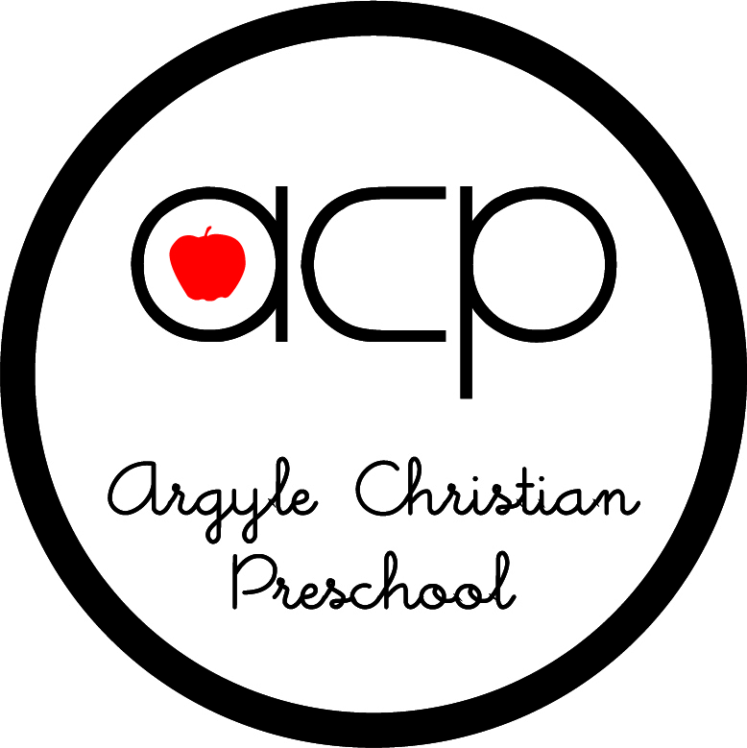

COMMUNICATION:

PARENT/TEACHER CONFERENCES
Conferences can be scheduled throughout the year at the request of parents or staff members. Since it is necessary for the staff to devote their time during the school day to the children, we ask that you schedule a conference time with the teacher to discuss concerns rather than trying to discuss concerns during classroom time. Conferences are scheduled with each family before school starts and a conference day has been scheduled for April 19th this year. There will be no school on this day so that the day can be spent meeting with parents. Childcare will be provided for the time that you are meeting with your child’s teacher.
CONFLICT RESOLUTION

We believe it is important to maintain open and frequent communication between staff and parents. We want to share with you, as much as possible, the experience your child has at school. Please feel free to express any concerns that you may have. We believe in resolving problems by using the Matthew 18 principle. Please go to your child’s teacher with concerns first and then if you do not feel like they are resolved, please speak with the director.
DAILY FOLDERS

Each child will be provided with a daily folder. Teachers will place all notes, newsletters, calendars, and any other written correspondence in this folder. Please check the folder daily to remain current on the “happenings” of your child’s classroom and our school. In addition to the daily folder, parents may request a conference at any time. Parents may also contact the Preschool Office and leave a message for the teacher to call back regarding questions, concerns, etc. It is a priority of Argyle Christian Preschool to maintain strong communication with parents. Please know that “our door is always open.”

MONTHLY CALENDARS AND LETTERS

Another avenue of communication between school and home will be the monthly calendar and letter. On the first of each month, teachers will send home the calendar and letter to inform parents of teaching units, various activities, cooking experiences, etc. Please read them carefully and discuss them with your child.
WEBSITE/BRIGHTWHEEL/FACEBOOK
ACP uses the Brightwheel app. Through this app, parents will sign students in and out daily, You will receive notices from the school or your child’s teacher, and it allows you to communicate with teachers and staff as well. ACP has a website that is updated monthly and a Facebook page that will post information about upcoming events. IT IS AGAINST ACP PERSONNEL POLICIES FOR EMPLOYEES TO “FRIEND” PARENTS ON THEIR PERSONAL FACEBOOK PAGES.

The preschool office opens at 8:30 a.m. and closes at 2:00 p.m. each afternoon. Should you need to contact us outside of office hours, you may leave a message on the voice mail and the message will be retrieved when the office opens the following day.

PORTFOLIOS/ASSESSMENTS

Children in our 2’s and 3’s program are assessed twice yearly, while VPK students are assessed three times. A culmination of the child’s work and classroom pictures is collected and given to parents in a portfolio at the end of each school year.

OPEN HOUSE

We will have Open House once during the year to give the parents a chance to view the classroom, children’s artwork, and the opportunity to fellowship with the teacher and other parents. Please remember that this does not take the place of a parent/teacher conference. If there are specific issues, please make an appointment to speak with your child’s teacher.

EMERGENCY/SECURITY PROCEDURES

PARKING LOT/SCHOOL GROUNDS
- Please drive SLOWLY in our parking area. Your speed should be no greater than 5 mph through the parking lot. You never know when a small child will dash out from between parked cars. Please have the same consideration for the children of others as you would have for your own.
- Please do not leave children in your car unattended.
- Children cannot be unattended on school grounds at any time. They must be taken to and from the classroom by an adult.
FIRE/TORNADO DRILLS/WEATHER EMERGENCIES/LOCKDOWN
- A carefully planned evacuation route is posted in each classroom. Children will be given instruction during the first week of school on emergency procedures. They will exit through a designated door and proceed to a designated location a safe distance from the building.
- In case of weather emergencies (hurricanes/tornadoes) the children will crouch inside the hallway away from doors and windows. An emergency weather radio is on at all times inside the preschool office. There will be emergency fire drills once a month according to state law.
- Lockdown drills will be conducted each year.
RELEASE OF CHILDREN
Students will be signed out through your brightwheel app. Children will be released ONLY to those persons that either have your designated brightwheel code or that have been named on the enrollment form. Please keep the information current and do not share your brightwheel code with any person that you do not wish to pick up your child. To avoid giving codes to people only authorized for a one time pick up, parents must send a note advising the teacher and office of the person who is to pick up the child or you may call the school. In special situations regarding child custody and the release of the child, the Preschool office must have a copy of the official judgment to ensure the protection and safety of the child.

VISITATION

We invite parents to visit the school. Please call the office and let us know when you would like to come or arrange a time with your child’s teacher. We ask that you do not plan to visit the school during the first month your child is enrolled. Children need that time to adjust to the new surroundings. You must enter the doors between buildings B and C and sign in and receive a sticker in order to visit the classrooms.

VOLUNTEERING/FUNDRAISING

PARENT TEACHER FELLOWSHIP (PTF)

- The Parent Teacher Fellowship is an organization that provides support for our school, an opportunity for parents to work in cooperation with the staff in many wonderful activities and worthy causes, and a forum for parents and teachers to discuss issues concerning the development and needs of children. Parental involvement is encouraged because early childhood programs are not a substitute for the home, but rather an extension of it. We ask that you make an honest effort to attend programs, orientation, and all other school programs whenever possible.
- The PTF has been working for our school for many years. They have coordinated such events as Fall Festivals, Western Nights, Craft Bazaars, Art Auctions and Dinners and Spring Flings, Community Service projects, Annual meetings, Teachers Appreciation and more. The fundraising efforts of the PTF have purchased such items as playground equipment, library supplies, computers and many other items that are well loved and well used at our school.
- Every family will have the opportunity to join and support this important organization. A new PTF board will be formed yearly at which time you will be invited to participate. Please consider using your gifts and abilities to contribute to your child’s school.

FUNDRAISING

Because Argyle Christian Preschool is a non-profit organization, the tuition payments that are made to the school are used to cover teacher’s salaries, classroom supplies, administrative and janitorial costs. Special events such as Western Night, Pumpkin Patch, Spring Fling and big-ticket items, such as computers, playground equipment and other major school improvements are often paid for by the PTF, which acquires all of its funding from fundraisers. Fundraising structure changes each year. We have in the past voted on parent contributions in lieu of fundraising. You will be informed of the PTF’s plans for this year.

VOLUNTEERING

All parents are encouraged to participate in our school by volunteering, whether it be working with the PTF, taking home projects to help your child’s teacher, or helping in the classroom. VPK parents of part-time students are required to participate by volunteering a minimum of four hours each year. This requirement can be completed by participating in any of the aforementioned ways. We ask that you have logged at least 2 volunteer hours by Christmas break. Because of this requirement, it is important that you keep track of your hours by using a volunteer sign in sheet. These sheets can be obtained from the school office and given to your child’s teacher once your four hours have been completed. We have gone the extra mile and are asking you to invest your time, rather than your finances, in our school. Unfulfilled voluntary obligations could result in the dismissal of your child.

FIELD TRIPS

A few times during the year, the three and four year old classes will participate in a field trip for educational benefit. Due to reservations for field trips, fees are non-refundable. A parent or responsible adult must accompany each child on all field trips. In lieu of field trips, sometimes special guests, such as police officers, dentists, fire fighters, etc., will come and visit the classroom.



WITHDRAWALS

If a child must be out for an extended time, he/she must be withdrawn and then re-enrolled later if a space is available. There is a re-entry fee. If it becomes necessary to permanently withdraw your child, a one-week written notice is required so the vacancy can be filled. Previously paid tuition will not be refunded, and tuition owed will still need to be paid.

If a child does not adequately adjust to the school setting within a reasonable time frame (approximately three months) and after conferences with parents, it is at the discretion of administration to request the child’s withdrawal.

CHILD ABUSE

All teachers are required to read and sign the pamphlet stating that they are aware that it is their responsibility to report any signs of child abuse. Teachers are mandated reporters and can be prosecuted with a felony for neglecting to report even suspected abuse. Teachers are not permitted to spank or abuse children in any way - verbally or physically.

BULLYING

James 4:11-12
My friends, don’t say cruel things about others! If you do, or if you condemn others, you are condemning God’s Law. And if you condemn the Law, you put yourself above the Law and refuse to obey either it or God who gave it. God is our judge, and he can save or destroy us. What right do you have to condemn anyone? (CEV)
Mark 12:31
And the second, like it, is this: ‘You shall love your neighbor as yourself.’ There is no other commandment greater than these. (NKJV)
Romans 12:18
Do all that you can to live in peace with everyone.

BULLYING DEFINED:

Bullying is the wi1lful, conscious and persistent desire to cause, often planned, emotional, verbal and/or physical hurt to another. This hurt may be caused by actual or anticipated actions which put the victim under stress. These actions are accompanied by an awareness of the impact of the behavior of the child who is the victim. The characteristics of bullying suggest that the child who is bullying, has reached a state of cognitive development where they are able to plan to cause distress in another. But it is sometimes hard to distinguish bullying from hurtful and/or inconsiderate behavior. Bullying can take many forms, but the main types are:

- Emotional: being unfriendly or unkind, excluding from groups, tormenting (hiding objects, threatening gestures)
- Physical: hitting, pushing, punching, pinching, kicking, hiding, taking, or defacing belongings, or any use of violence, Racist/Intolerant Taunts, slurs and/or physical threats directed around a victim’s race, religion or ethnicity.
- Verbal: name-calling, teasing, sarcasm, spreading rumors, making prejudiced remarks Please note that an instance of bullying may fall into more than one ‘category’ listed above

If a child hurts another child or children: • we intervene to stop the child harming the other child or children; • we explain to the child exhibiting the harmful behavior, why her/his behavior is inappropriate; • we give reassurance to the child or children who have been hurt; • we help the child who has done harm to say they are sorry for her/his actions; • we make sure that children who are hurtful receive praise when they display acceptable behavior; • we do not label children who cause harm; • when children are hurtful, we discuss what has happened with their parents and work out with them a plan for handling the child’s behavior; and • when children have been harmed, we share what has happened with their parents, explaining that the child who did the hurtful thing is being helped to adopt more acceptable ways of behaving.

GUIDELINES FOR DISCIPLINE

The term “discipline” is intended to mean “guidance that improves, strengthens, molds and helps a young child control his/her own actions.” Positive guidance used by loving teachers in an enriched environment suited to the child’s level of development can promote desirable, acceptable, and satisfying behavior. Discipline is helping the child learn self-control and self-direction. Therefore, it is the desire of Argyle Christian Preschool to establish this kind of environment in each classroom.

Within Argyle Christian Preschool, we use the following guidelines to enhance positive behavior:

- We model appropriate behavior for children.
- We teach children what to do rather than what not to do.
- We avoid asking the question “why?” This type of question is detrimental to the child’s image.
- We create a classroom environment that encourages pro-social behavior.
- We understand developmental stages.
- We give children a definite time when we want something done.
- We provide choices only when we are willing to accept whatever choice the child makes.
- We nourish the roots, giving love with warm eyes and a kind, but firm, tone of voice.
- We use buffers to stop aggression by stepping in before an inappropriate act begins.
- We teach communication skills.
- We ignore inappropriate behavior whenever it is safe to do so.

Time-out is probably one of the most misused guidance techniques. We prefer to use the thinking spot rather than time-out. This simply involves removing the child from the group for a brief time. The child is never in time-out for longer than five minutes because of his/her limited concepts of time. It is not a fearful or threatening time, but a time for the child to calm down. After the child has calmed down, the teacher will talk to the child about his feelings. The thinking spot is used sparingly and is called “taking a break” or sitting in the “thinking spot”. Its effectiveness is lost when used constantly.

PLEASE NOTE that the Director, Teacher or other personnel do not permit corporal punishment (spanking).

DISMISSAL

If a child’s behavior is found to consistently disrupt the class and the learning process, the child will be subject to dismissal. If a conference, which includes parent(s), teacher, assistant, and school director, does not produce a satisfactory change in behavior, another conference will be scheduled. Two weeks written notice will be given to the student’s parent(s) if withdrawal actions are recommended. If a child is harming teachers or other children, we reserve the right to shorten notice as needed for safety.

PARENT CODE OF CONDUCT

A code of conduct for parents and visitors ensures that everyone who visits the school site can do so in a safe and harmonious manner and to ensure that students, staff, parents, and other visitors are not subjected to aggressive, hostile, or violent behaviors.

Parents and visitors are expected to:

- Treat everyone on campus with respect and courtesy.
- Ensure their child/children are punctual to class.
- Discuss issues or concerns about the school, staff, or students through the correct procedures. (i.e., teacher or administration).
- Follow school procedures governing entry (see entry procedures) and behavior on school grounds.
- Respect the confidentiality of other children when volunteering in the classroom.
The following occurrences are prohibited on ACP/TCAA property:

- Approaching another person’s child without permission.
- Actual physical assaults or threatened physical assaults.
- Behavior in the presence of students, staff, parents, or other visitors to the school, that causes alarm or concern to the students, staff, or other visitors.
- Use of offensive language (i.e., swearing) in the presence of students, staff, or other visitors to the school.
- Interruptions to the learning environment without permission.
- Speeding, unsafe operation, or using cell phone (talking or texting) while driving in the parking lot.
- Leaving children in the car while dropping off or picking up.
- Smoking
Failure to abide by this code of conduct may result in the dismissal of your child from ACP.

ACP EXTENDED DAY

The Extended Day Program is offered to 3 year olds and VPK students who are enrolled in Argyle Christian Preschool. The program will operate on weekdays from 7:00 a.m. to 6:00 p.m. The program is offered during the school year, and registration permitting, summer care is offered from May 20, 2024 through July 26, 2024 except for the following days:

Extended closings:
August 12, 2025, at 7:00 pm Preschool/VPK Orientation
August 13, 2025 First Day Preschool
August 13, at 9:30 a.m. Preschool/VPK Orientation
September1, 2025 Labor Day No School
November 11, 2025 Veteran’s Day No School
November 26-28,2025 Thanksgiving Break No School
Dec 9, 2025-Jan 1, 2025 Christmas Break No School
January 2, 2026 Planning Day No School
January 19, 2026 Martin Luther King Day No School
February 16, 2026 President’s Day No School
March 12, 2026 Spring Fling Early Release
March 13, 2026 Planning Day No School
March 16-20, 2026 Spring Break No School
April 3, 2026 Easter (Good Friday) No School
April 24, 2026 Parent/Teacher Conference Day: NO School
May 12, 2026 VPK/4-year-old Celebration
May 13, 2026 Last Day of School
Summer Closings:
May 25, 2026 Memorial Day Holiday No School
June 19, 2026 Juneteenth No School
July 4, 2026 Independence Day No School

Drop off and Dismissal:

Children may be dropped off no sooner than 7 am. And no later than 8:40am. If arrival is 8:41 or later, students must be dropped off through car line. Extended care is a wrap-around program for preschool. Preschool hours are 9:00-12:30 and 9:00-1:00. Children must be in attendance during those hours to participate in extended care. ACP is not a daycare.

When picking up your child after school hours, please ring the doorbell at the school office doors and a teacher or administrator will assist you with drop off and pick up procedures. You will need an electronic device to scan the Brightwheel QR code.

Late Pick Up Fees:

ACP closes at 6:00 p.m. For any child picked up after 6:00 p.m. the following late fees will apply: $25.00 after 6:00 for the 1st 15 minutes and $25.00 for each 15 minutes thereafter. Late pickup will not be tolerated on a consistent basis. Our facilities close at 6:00.

Naps:

A nap time or quiet time is required for all students in extended. An environment for quiet time, rest and soft music is created. Nap/quiet time will be from 1-2:30pm. Please make arrangements for early pick-up either before or after this time so as not to disrupt their time of rest.

Cots are provided by ACP for Naptime, but a travel size pillow and blanket should be brought each Monday and taken home on the weekends to be washed.

Breakfast/Snacks/Lunches:

For children who are dropped off at least ½ hour before preschool starts, breakfast may be consumed. Simply send the breakfast item labeled with your child and make sure you let the teacher know that the child has not eaten yet. Do not send doughnuts, pastries, or sugary snacks for breakfast.

It is recommended that children who are enrolled in the program have a lunch that meets USDA requirements. Suggestions for lunch include 1 serving of 1 ½-2 oz of protein, 1 serving of ½ - ¾ cup fruit, 1 serving of ½ - ¾ vegetables, and ½ slice of bread. Other items may be included in your child’s lunch, but they should not replace the recommended components. Canned drinks and candy are NOT allowed. Remember items that contain peanuts or nuts or are prepared in factories that process them are not permitted. If needed, please put an ice pack in your child’s lunch box. We cannot accommodate refrigerated items.

An additional healthy snack item along with a drink should be clearly marked for aftercare.

ACP PLAN FOR CHILDREN WITH SUSPECTED DEVELOPMENTAL DELAYS

From time to time, by observation of the children in the classroom, a teacher may have cause to suspect a developmental delay in a child. The following is the protocol which is followed in regard to this observation. Keep in mind that while trained to recognize delays, a teacher is not a specialist or a doctor and cannot diagnose children.

- Teacher observes child; writes down areas of concern and continues to document.
- Teacher speaks to the director about concerns.
- Teacher speaks to parent about concerns; director can be involved in meeting with parent.
- Referral to Childfind or suggestion for parent to get help through pediatrician is implemented.
- Accommodation is made for this child during this time as needed if there is no physical danger to classmates and if the child is safe.
- Seek guidance from director or research ideas for accommodations.
- Communication is consistent with parents to see where child is in the process of being evaluated.
- If therapy is provided, the school welcomes therapists in the classroom.
- Teachers communicate with therapists and implement suggestions that can help in the classroom.
- Often a child’s needs are more than can be handled at ACP. Children are typically transferred to a full-time program in this case.

Goal: Our goal is to identify red flags that indicate a delay; relay concern to parents, point parents towards sources of help, and stick with them until a plan is formed. We will treat each child as a valuable and loved member of our class and will make accommodations as recommended by therapists or on our own until therapy is available.

Pandemic Policy Covid-19

ACP has implemented safety measures for families, children, and teachers to follow so that we are an essential part of reducing the spread and keeping everyone as healthy as possible.

Argyle Christian Preschool staff and families will work with The Florida Department of Education, The Early Learning Coalition, the CDC, the American Academy of Pediatrics’ guidelines and the local health officials to determine a set of strategies appropriate for our center. The guidelines are consistently changing, and we will be following recommendations for these changes as they occur.

TECHNOLOGY

Technology is used in moderation and always intentionally. It enhances but never replaces hands-on, play-based, teacher-guided learning.
Technology may be used in short, purposeful intervals and always under staff supervision. ACP emphasizes developmentally appropriate use that supports the WEE Learn curriculum and Christian worldview.

CLASSROOM EXPECTATIONS:

• Technology is primarily teacher-directed
• Children do not have independent, free-access screen time
• VPK students may use structured phonics tools for learning reinforcement

APPROVED TECHNOLOGY:

• Echo Dots for music, stories, Bible songs, and instructional supports
• Teacher tablets for lesson enhancement and documentation
• Shared TV for displaying visual supports and videos
• VPK phonics buttons

THE TWO YEAR-OLD

BEHAVIOR PROFILE

At two years of age, the child is no longer an infant, although compared with a three-year old, he is still very immature. There is a danger of overestimating the child’s capacities simply because he is sturdy on his feet and is beginning to put words together. He is still an infant-child and has so many behaviors to coordinate and organize that we must stress his limitations as well as his prodigious capacity for growth.

He does not yet walk erect - he tilts forward. Knees and elbows are slightly bent; shoulders are hunched. He holds his arms out and backward. When he picks up something from the floor, he half bends at the waist as well as at the knees. Stooping is a more advanced behavior pattern than squatting. The two-year-old still leans forward as he runs. Should he fall, he would bruise his forehead; at two and a half he would hit his nose; at three, his teeth.

To get up from a sitting position on the floor he leans forward, pushes up buttocks first and head second, instead of raising an erect trunk as he will later. He goes up and down stairs in “mark time” fashion without alternating feet. He can kick a ball, but he cannot stand on one foot, as he will in another year. There is not much spring in his knees. The knee joints become flaccid or rubbery when one tries to slip on his pants. He is rather hard to dress, even though he is cooperative.

He is still geared to gross motor activity and likes to run, romp, lug, push and pull. His fine motor control has also advanced. He can crudely imitate a circular stroke. He manipulates more freely with one hand and alternates from one hand to the other. He rotates his forearm, which enables him to turn a doorknob. This increased manipulatory skill expresses itself in his marked interest in fitting one thing into another. “It fits” is a favorite expression. He also likes to take things apart and fit them together.

The whole linguistic apparatus (mouth, lips, tongue, larynx, and thorax) is undergoing rapid organization. The two-year-old speaks in short sentences. He repeats words, names things, suits words to actions and actions to words. Vocabularies vary enormously in size from a half dozen to a thousand words.

The socialization process of the two-year-old is not yet sufficiently advanced enough to initiate and maintain delicate and long sustained interpersonal relations. He still prefers solitary play to parallel play and seldom plays cooperatively. He is in the pre-cooperative state, watching what others do rather than participating. He cannot share; he cannot, as a rule, let someone else play with what is his own. He must learn “it’s mine” first. He does so by holding on and by hoarding. This is not a vice. How can he possibly acquire pride of ownership any other way? It is the method of development. Keeping and sharing are not separate virtues; they spring from the same developmental root. The hitting, poking, biting, hair-pulling, and tugging over materials, so characteristic of twos, needs to be handled with understanding and sensible techniques on the part of the parent and the teacher. The two-year-old is still too young to be reached by words alone; he must organize his experience through touching, handling, holding, clasping and even a little hoarding and running away.

Two-year olds must feel familiar with things- toys, food, clothes, and routines. They like the sense of security that the same arrangement of furniture, for example, gives them. Much repetition is important.

To sum up, the two-year-old - what are his dominating interests? He loves to romp, flee, and pursue. He likes to fill and empty, put in and take out, tear apart and fit together, taste (even play dough and wood), to touch and to rub. He prefers action toys such as trains, cars, and telephones. He is intrigued by water and washing. Although is not yet a humanitarian, he likes to watch the human scene. He imitates the domesticities of laundry work and doll play. He has a genuine interest in the mother-baby relationship.

THE DAILY PROGRAM

- Arrival and Greeting the Children
- Working at Activity Centers
- Clean-up and Transition
- Short Group Time
- Rest Room Time
- Snack Time
- Outside Time
- Working at Activity Centers
- Group-Story Time
- Departure

SOME OF THE UNITS OF STUDY

Self Plants
Family Foods We Eat
Where Mom’s and Dad’s Work Pets
Community Workers Farm Animals
How People Travel Zoo Animals
Seasons Others

Each child’s total self must be dealt with. Because he comes to school with a variety of needs - social, intellectual, spiritual, emotional, and physical - our curriculum is designed to enable the child to experience success and positive feelings about himself and others. Overlapping between unit concepts, repetition of conversation, songs and activities will reinforce the learning process for twos.



THE THREE YEAR OLD

PHYSICAL CHARACTERISTICS

Three year olds are usually energetic and experience rapid growth. They need much room to play and exercise their growing bodies. Their bodies demand constant action. Threes can walk and run well, walk up and down steps alone, walk on tiptoes and jump with both feet. They are experiencing large muscle development.

New independence is gained as three year olds continue to develop self-help skills. Most are able to feed, toilet, dress and undress themselves. Fine motor skills begin to develop as large motor skills continue their growth. Not only can the average three year old kick, throw and swing, but his finger dexterity and manipulation are improving.

INTELLECTUAL CHARACTERISTICS

Three year olds need the challenge of new ideas to stimulate and stretch their minds. They now have a limited vocabulary (approximately 1,000 words) and are beginning to have limited concepts of time and space. Curiosity leads threes to ask questions that provide information, which is valuable to intellectual growth. They are still literal minded and cannot interpret symbolic terms.

Developmentally appropriate concepts should be introduced a few at a time for maximum learning. Units of study offer opportunities to incorporate concepts such as:

Shapes - triangle, circle, square, rectangle
Colors - red, blue, green, orange, purple, white, black, and brown
Basics - over/under/through, in/out, inside/outside, up/down, high/low, bottom/top, night/day, dark/light, fast/slow, loud/soft, stop/go, big/little, open/close, stand/sit, soft/hard, rough/smooth, sweet/sour, bitter/salty, cold/hot, wet/dry, float/sink, first/last, happy/sad.

Three year olds are at a perfect age to expand their oral language development and explore the concepts that are the foundation for early literacy learning. Threes will listen to stories, discuss events, sing songs, participate in rhymes, and finger plays, solve problems, and even just “play with words.” This will help expand their language skills.

Most threes have vivid imaginations. People and objects can become whatever their minds imagine. They like to pretend to be someone else - doctor, police officer, farmer, mommy, and daddy. This vivid imagination often contributes to emotional fears of monsters or other creatures. Three year olds are also imitative. They learn much through this avenue. Imitation of others also can reveal how they see significant people in their lives. They are honest in their portrayal of moms, dads, and teachers.

SPECIAL CHARACTERISTICS

Three year olds are still quite self-centered but are learning to play with others. They continue to be possessive but are beginning to enjoy contact and play with other boys and girls. As this ability develops, threes have an early interest in taking turns, which is a foundation for sharing. They do not yet have the ability to interpret what another person’s feelings are, but they do have some recantation that others have feelings.

As a result of their social development, threes are increasingly friendly, are seeking approval of others, are growing in their struggle for independence, and are beginning to establish self-control. During this period, threes need activities that help them recognize the existence, needs, rights, and feelings of others. They need encouragement in choosing ways to express interactions and they need to know that other people love and care for them.

EMOTIONAL CHARACTERISTICS

The emotional feelings of anger or joy can be intense during the third year. The three-year-old is usually exuberant in his happiness but may explode when angry. Threes need firm and loving guidance to help control their feelings. They need opportunities to express their feelings and emotions in positive ways. They need to feel the emotional security of being loved and wanted.

MORAL/SPIRITUAL CHARACTERISTICS

If three year olds have had positive experiences with significant people in their lives, they are more likely to develop simple trust in people and in God. Much of what they are able to learn about God is learned through good relationships with others that demonstrate God’s love and care. Threes have the ability to recognize the Bible from other books. As they become more aware of Bible verses, their ability to apply these verses increases. They are able to put into practice such biblical concepts as kindness and helpfulness.

Threes are developing a conscience, desiring to please those they love and respect. Appropriate discipline is needed to develop self-control without creating shame or guilt beyond what they are able to handle.

Threes have important needs that must be met if they are to continue their growth as God planned.

THE DAILY PROGRAM
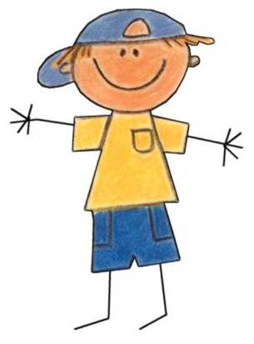
- Arrival and Greeting the Children
- Learning Center Activities
- Clean-up and Transition
- Large Group Time
- Rest Room Time
- Snack Time
- Outdoor Play
- Learning Center Activities
- Large Group Time
- Departure

SOME OF THE UNITS OF STUDY

Self (I Am Special) Seasons
Family Machines and Tools
Friends Pets and Birds
People Who Help Me Zoo Animals
Colors and Shapes Farm Animals
Health and Safety Communication

The three year old preschool class is designed to develop motor skills, social skills and much more. After completing the three-year-old program, children are better prepared for the four year old program because they have been allowed to be three year olds and their desire for experiencing new levels of learning has been encouraged.

THE FOUR YEAR OLD

STAGE: I AM WHAT I LEARN

VIEWPOINT

Four year old children have active minds and are versatile, going from one idea to another. They are very inquisitive and want to know the “why” and “how” of everything. They have vivid imaginations, which they enjoy using in dramatic play. They listen with interest to poetry and stories with actions, especially those explaining how things work. Four year olds are also very active physically. They explore people and places. They test their own bodily skills, running, jumping, skipping on one foot and then hopping on the other, standing on one foot throwing a ball overhead and cutting paper with scissors. These children know their colors and work hard on their drawings; they often change ideas as they draw. They concentrate on the details and sometimes combine a symbolic representation with a realistic object. They often draw a picture first, then name it.

I AM FOUR AND FOUR +

- I am mother’s helper.
- I am curious about everything I see and hear.
- I am big now and no longer talk baby talk.
- I am very interested in the world around me.
- When I grow up, I am going to drive a car like my daddy. My daddy is an important man.
- I know which hand I like to use best.
- It is still hard for me to get my hands to do little things because my eyes and hands won’t work together. I like to use my large muscles.
- I like to experiment with language.
- I like to make things. Please ask me to tell you about my picture instead of saying “What is it?” I know what it is!
- I learn best by seeing, hearing, tasting, smelling, and feeling.
- I like to imitate, observe, explore, examine, investigate, experience and question everything in my world.
- I want concrete and direct experiences rather than abstract learning; I am literal minded.
- I am still self-centered, but I like to work and play with other children.
- I need to be useful.
- I am devoted to learning.
- I am not ready for competition because I cannot stand losing.
- I need to have responsibilities in taking care of my things.
- I like games in which everyone has a turn; I like group games.
- I glow under praise; criticism, even when well-meant, will wilt me.
- I like to be rejoiced with when I do something recognizable for strenuous efforts.
- I may seem brash and boastful, but my confidence is very brittle; developing my self-esteem is crucial at this time.
- I can begin to work together in small groups.
- I can sit still longer, but it is not easy for me.

.
Four-year-old children are acquiring basic attitudes about God, Jesus, the Bible, themselves, and others. They ask questions, such as: “Who is God?”, “Who made God?”, “Who made the sun, moon, and stars?” and “Why can’t I see God?” These children enjoy simple Bible stories about Jesus. Their concepts are gained through adult’s attitudes, feelings and actions toward God and man. Their basic outlook on life is established by age five.
THE DAILY PROGRAM

- Arrival and Greeting the Children
- Learning Center Activities
- One on One Student/Teacher Time
- Clean-up and Transition
- Large Group Time
- Snack Time
- Rest Room Time
- Outside Play
- Learning Center Activities
- Large Group and Story Time
- Departure

SOME OF THE UNITS OF STUDY

Starting to School Life in Bible Times
Discovering Myself Tools and Machines
How I Grow Plants and Animals
Where I Live Community Helpers
Four Seasons Foods
Health and Safety God’s World Around Me

The four-year-old preschool class is designed to develop motor, social, and cognitive skills, as well as the child’s emotional, moral, and spiritual areas of growth.

Reading readiness skills will be enhanced with a focus on promoting phonological awareness and building alphabetic skills and letter identification. The children will be provided with a wealth of literature experiences as they learn about each letter and the sound represented by that letter. Letter play, letter identification and plenty of opportunities to “write” are introduced early on. The skills that are developed this year will help your child transition smoothly to the kindergarten environment.

RESOURCE CLASSES

Four year olds will participate in Music and STEM Resource classes, as well as attend chapel once a week on Wednesdays. The library will also be incorporated as individual teachers see fit.



Argyle Christian Preschool
Expected Spiritual Outcomes
Jesus and God:
• The child learns that God sent Jesus to earth.
• The child becomes aware that Jesus is God’s son, and that He came to earth to tell people about God.
• The child is aware that God and Jesus love all people.
• The child understands that Jesus came to earth as a baby and grew as he grows.
• The child learns that Jesus did things that they cannot do.
• The child is aware that God always does what he said he will do.
• The child understands that Jesus did everything that God told him to do.

The Bible:
• The child becomes aware that the Bible is a special book.
• The child is aware that the stories in the Bible are always true, and the people in the stories are real.
• The child knows that the Bible teaches him the right things to do.
• The child is aware that the Bible teaches him about God and Jesus.

Prayer
• The child understands that when he prays, he is talking to God
• The child knows that he can talk to God any time, any place.
• The child understands that he can ask God to help him or help other people.
• The child knows that he should thank God.

Creation:
• The child becomes aware that God made everything around him.
• The child knows that he is special because God made him.
• The child understands that God made people alike and different.
• The child will know that God wants us to take care of our world.

Self:
• The child will understand that he is special and there is no one else like him.
• The child knows that God will always love him.
• The child will take pride in his own work and will know that God also delights in his work.
• The child is aware that God made him so that he can think, work, play, and do what God wants him to do.
• The child will learn to take turns and share.

Family/Others:
- The child is aware that God wants us to love one another and be kind to one another.
- The child will learn that it is important to be obedient to his parents, and those who are in authority.
- The child is aware that God likes for us to help others around us and to tell them about Jesus.
- The child will learn that God made people alike and different.
Church:
- The child becomes aware that people learn about God and Jesus at church.
- The child will know that church is a special place where everyone is welcome.

ACP Expected Social/Emotional Outcomes
Self:
- Child uses language to express both positive and negative emotions.
- Child attempts to take care of personal needs.
- Child begins to understand and control their emotions.
- Child gains competence through age appropriate activities.
- Child attempts to solve problems.
- Child adjusts to minor changes in schedule.
- Child will master new skills through encouragement and direction from teacher.
- Child begins to understand and control emotions.
- Child will gain competence through age appropriate activities.
- Child will master new skills through encouragement and direction from teacher.

Others:
- Child chooses to work and play with others.
- Child learns to share and take turns.
- Child develops friendships with children from different cultures, family backgrounds and abilities.
- Child learns to resolve conflict without adult help.
- Child begins showing empathy and kindness to family members and friends.
- Child enjoys and participates in interactions with other adults and children.
- Child develops the ability to respond to communication with others.
Environment:
- Child learns to show respect for others and their property.
- Child will choose activities and complete them.
Child becomes aware of the surrounding community.

ACP Expected Physical Outcomes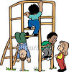
Gross Motor:
- Child will combine movement with proper equipment.
- Child actively pursues gross motor activity.
- Child will explore and refine fundamental movements of balance, movement, touch, and coordination.
- Child moves in various speeds, directions, levels, and rhythms.
- Child explores ways to move from one place to another.
- Child maintains balance while moving.
Fine Motor:
- Child uses appropriate equipment (crayons, markers, pencils, scissors, paintbrushes, etc.) that aids in the development of fine motor skills.
- Child will explore ways to move fingers, hands, and arms.
Health and Safety:
- Child will recognize that the body is created by God.
- Child can name body parts.
- Child develops good hygiene habits and knows that they must take care of their body.
- Child is introduced to health and nutrition.
- Child can make good food and activity choices.
- Child is aware that his body is growing and changing.
- Child practices indoor and outdoor safety procedures.
- Child practices safety precautions in case of emergency.

ACP Expected Cognitive Outcomes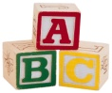
Creative Expression:
- Child uses imagination in dramatic play.
- Child creates unique artwork by using mediums provided in the art center.
- Child is encouraged to express creativity and is provided materials for free expression.
- Child makes up stories and songs.
Language, Literacy and Communication: (Listening, Speaking, Writing)
- Child identifies rhyming words.
- Child can recall events and tell stories.
- Child can answer questions regarding a story they have heard.
- Child listens to stories, poetry and songs with enthusiasm and desires to look at books with text and illustrations.
- Child identifies rhyming words.
- Child expresses his own ideas and feelings about his experiences.
- Child will participate in receptive language activities.
- Child will become phonemically aware through specifically designed classroom activities.
- Child shows an awareness of sounds.
- Child participates in activities to develop small muscle control.
- Child understands that the written word holds meaning.
- Child handles paintbrushes, scissors, crayons, and pencils with ease.
- Child is able to print his own name conventionally or unconventionally and is able to write some alphabet letters.
Math and Science concepts
- Child will have appropriate sorting, patterning, measuring, counting, and comparing (bigger, smaller, longer, taller, etc.) skills.
- Child will recognize some numerals and match them with a corresponding number of objects.
- Child will discriminate differences in geometric shapes.
- Child recognizes an existing problem and asks questions.
- Child investigates and labels the attributes of things.
- Child makes judgments based upon evaluation of possible solutions.
- Child explores ideas about people, animals, weather, plant live, seasons, air, and water.

ACP Expected Outcomes for Families 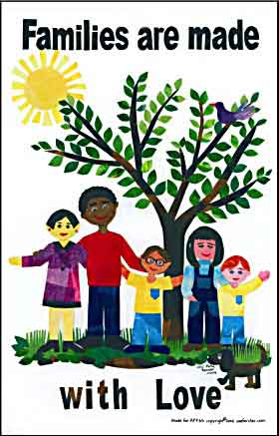

- We will develop a relationship of trust and mutual respect.
- We will provide support and minister to the needs of families.
- We will build a partnership with parents in providing the best educational experience for their child.
- We will provide quality care and development for each child to reach his/her greatest potential spiritually, mentally, physically, socially, and emotionally.
- We will equip children and families with the ability to thrive and prosper in this environment, as well as prepare them to thrive in their next educational environment.
- We give parents an understanding of the importance of Christian education.

