Argyle Christian Preschool

September 2025 Newsletter

**Welcome Back!!!**

.

***Important Dates:***

**Labor Day:**

September 1st:

No School

**PTF Meeting:**

September 2nd

**Individual School pictures:**

September

17th and 18th

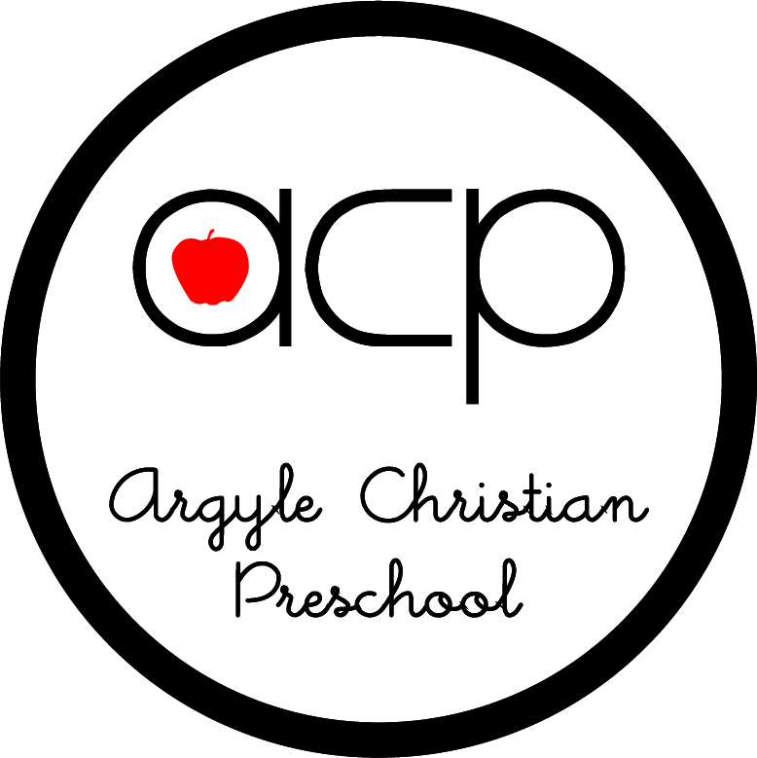

**Don’t forget to scan your**

**Box Tops for Education** 

We’ve had a wonderful first couple of weeks of preschool at ACP. The classrooms are already hustling and bustling and overflowing with fun activities and happy preschoolers. We have painted, played with blocks and letters, made new friends played in dramatic play, played on the playground, learned about school, Jesus, and a multitude of other things. We are so blessed by all the wonderful families that God has brought this year and are looking forward to the opportunities that this year holds.

PTF

I am so appreciative of those of you who have supported us in the past by being a part of our wonderful Parent Teacher Fellowship and look forward to partnering with you as well as with those of you that are new to our school this year.

**Facebook**

ACP has a Facebook account, and each class has a page of their own as well. This page can be accessed through our website.

Our Facebook name is Argyle Christian Preschool. To join your class Facebook, go to the Parent tab and click on the class that you are trying to join. This is another great way to stay informed regarding happenings at our school.

**Immunization, Physical forms**

We are required by the State of Florida and ACSI to have both state forms in your child’s file. These are due by September 15th. If we do not have these forms on file by this date, your child may not be able to attend until the forms are obtained.

**Website**

Our website is a great resource containing consistently updated information, newsletters, calendars, and everything you need to know about ACP. [www.acpjax.com](http://www.acpjax.com)

**Picture Day**

Pictures are scheduled for September 17th and 18th.

Your child’s teacher will let you know which day they will have pictures.

As always, I am always open to and available for questions and concerns. Thank you so much for sharing your child with us.

Blessings in Christ,

Paula Chambers

Director

**"Jesus said, 'Let the children come to me, and do not hinder them, for the kingdom of heaven belongs to such as these.'" Matthew 19:14**