In this last newsletter of the year, I’d like to tell you how wonderful it has been to be in the presence of your children. I have truly loved watching them learn and grow over the past year. They come seeking instruction in many, many areas and wind up, while receiving that instruction, teaching us many lessons along the way; lessons about life and lessons about God. Truly the young have the purest hearts. If we could only learn to look at the world through their eyes from time to time, we’d surely gain a lot of knowledge regarding what is REALLY important in life. The most important bit of knowledge that I hope that they will take with them this year is the knowledge that God loves them and that He created them so that they could have a relationship with Him. I pray that this is only the beginning of a young life seeking God.
Important Dates:

May 6-10:
Teacher’s Appreciation Week

May 14:
VPK Graduation 11:00

May15:
Last Day of School

May 20:
First day of Summer Program

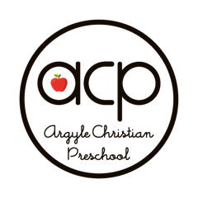

“I will instruct you and teach you in the way you should go; I will counsel you and watch over you”. Psalm 32:8

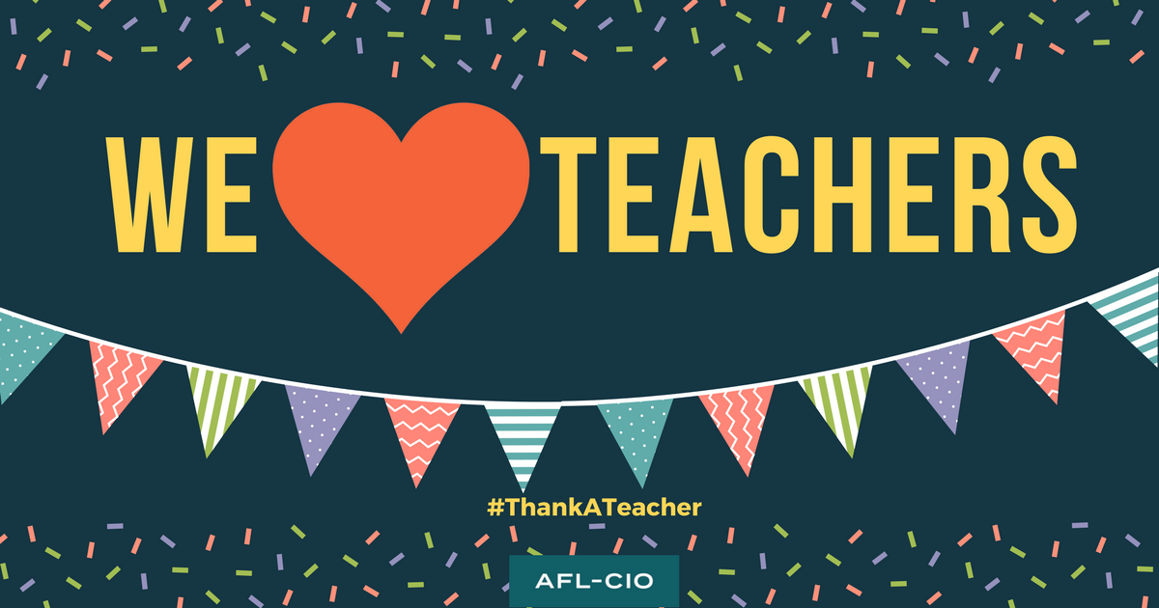

Teacher’s Appreciation week is scheduled for May 6th-10th. We are so blessed to have such caring, faithful teachers. Join us in showing them some love!

Follow your class calendars closely, as there are some fun events planned for the remainder of the year. Also check your calendars for Water Play Day. You will want to send your child dressed appropriately for this fun day.
May 14th is a special day for our 4-year old classes. Our annual VPK Graduation will be held on that day. Graduation begins at 11:00 in our Worship Center with a short presentation performed by your preschoolers. Please schedule accordingly. You won’t want to miss this special event!

Please spread the word about our precious school. There are still spots available for next school year.

The last day of school for all students is on May 15th. Our summer program begins on May 20th.

For those of you who are spending your last days with us, please know how blessed we have been to be a part of your lives for this period of time. Thank you for sharing your children. It has been such an honor to be a part of this special school for so many years.

Each year we are presented with hurdles, yet I watch teachers and children overcome, bond, and grow in a way that is truly special. My time here has taught me to cherish and find joy in the small things. I love each and every one of your children and pray for great things in their future endeavors.

In His Service, Paula Chambers, Director

