  - Argyle Christian Preschool
  - September 2023 Newsletter

Welcome Back!!!
.

Important Dates:
Labor Day:
September 4th:
No School
PTF Meeting:
September 5th
Individual School pictures:
September
20th and 21st

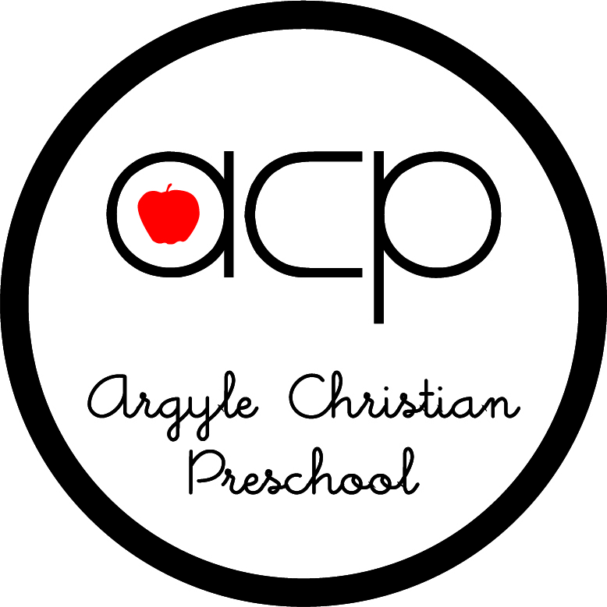

Don’t forget to scan your
Box Tops for Education
We’ve had a wonderful first couple of weeks of preschool at ACP. The classrooms are already hustling and bustling and overflowing with fun activities and happy preschoolers. We have painted, played with blocks and letters, played in dramatic play with our friends, played on the playground, learned about school, Jesus, and a multitude of other things. We are so blessed by all the wonderful families that God has brought this year and are looking forward to the opportunities that this year holds.

PTF
I am so appreciative of those of you who have supported us in the past by being a part of our wonderful Parent Teacher Fellowship and look forward to partnering with you as well as with those of you that are new to our school this year.

Facebook
ACP has a Facebook account, and each class has a page of their own as well. This page can be accessed through our website.

Our Facebook name is Argyle Christian Preschool. To join your class Facebook, go to the Parent tab and click on the class that you are trying to join. This is another great way to stay informed regarding happenings at our school.

Immunization, Physical forms
We are required by the State of Florida and ACSI to have both state forms in your child’s file. These are due by September 15th. If we do not have these forms on file by this date, your child will not be able to attend until the forms are obtained.

Website
Our website is a great resource containing consistently updated information, newsletters, calendars, and everything you need to know about ACP. www.acpjax.com

Picture Day
Pictures are scheduled for September 20th and 21st.
Your child’s teacher will let you know which day they will have pictures.

As always, I am always open to and available for questions and concerns. Thank you so much for sharing your child with us.

Blessings in Christ,
Paula Chambers
Director

"Jesus said, 'Let the children come to me, and do not hinder them, for the kingdom of heaven belongs to such as these.'" Matthew 19:14

